Peninsula News Review
Nick Murray

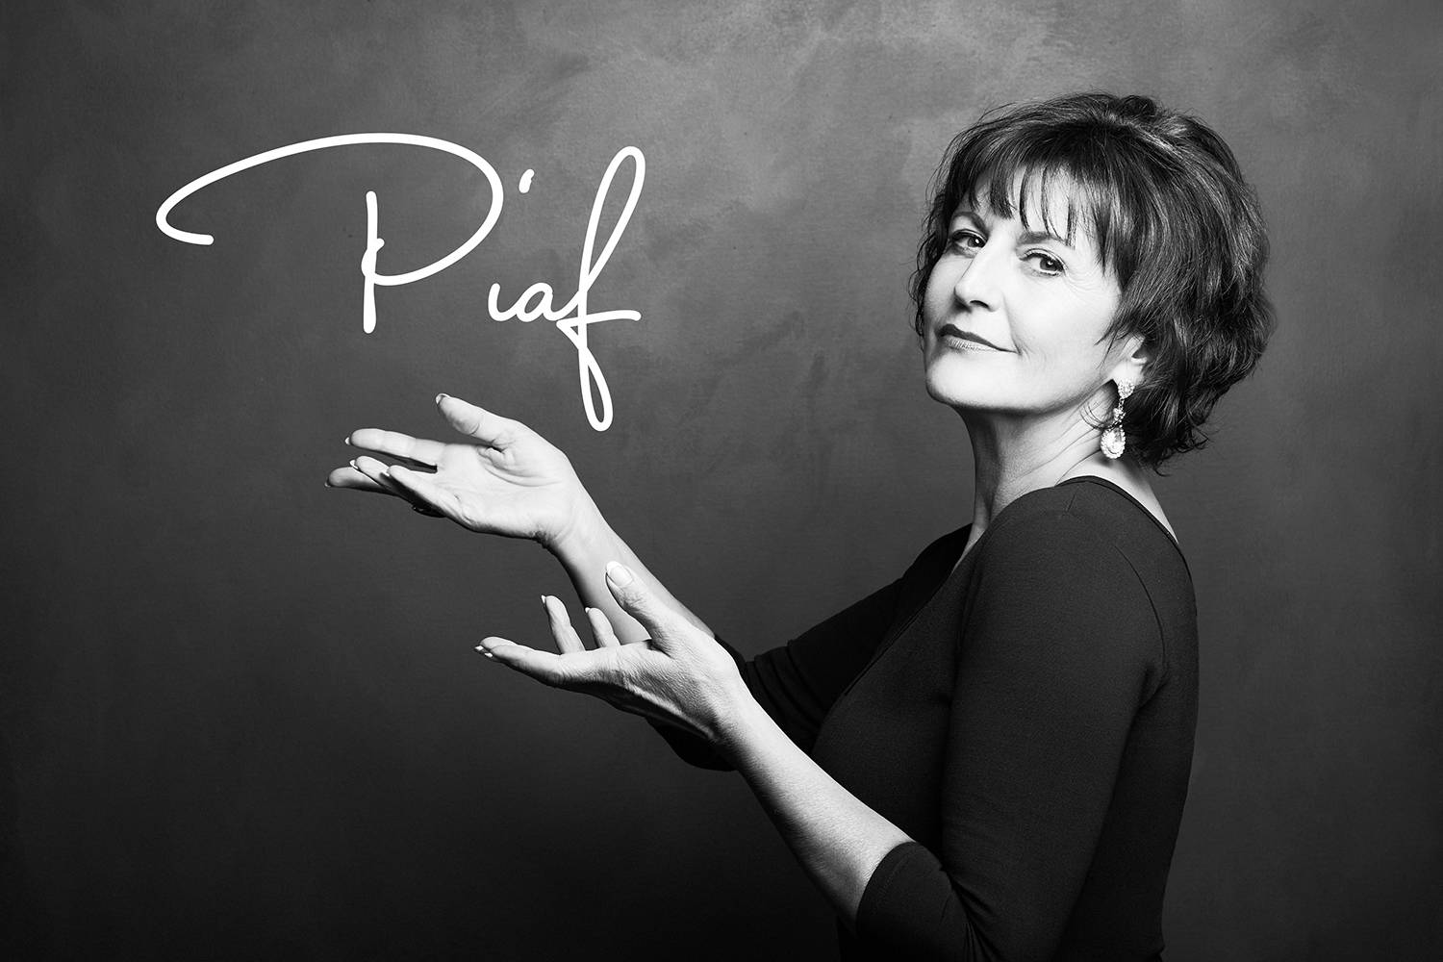
Edie Daponte is performing the works of French cabaret singer Edith Piaf on an eight-city tour, this fall. (Michelle Alger photo)

Edie Daponte set to take Edith Piaf show on eight-city B.C. tour
Under Paris Skies to be performed after busy summer season wraps
Sidney favourite Edie Daponte wraps up her local shows this summer with a finale in Sidney, before embarking on a provincewide tour.
With a repertoire that includes blues, jazz and singing in multiple languages, Daponte has built a loyal local following in Greater Victoria and up the Saanich Peninsula.
Since the turn of the year she has enjoyed a whirlwind schedule of events, performing at local concerts, private functions and even the Victoria International JazzFest. This summer she has a few more dates, singing in Vancouver and Peninsula wineries, before closing the Sidney Summer Sound on Aug. 25.
Daponte is known for her musical literacy and ability to perform in different styles, and has enjoyed a variety of ensemble performances recently. As well as singing in a duo, she has also sung with the 18-piece Don Leppard Big Band at her back.
“I can’t tell you what a musical thrill it is to have that amount of musical power in your ears as you’re singing. It’s kind of like getting on a freight train,” she says with a laugh. “Once you’re on it you’ve got to keep going. It’s a big ride.”
Since the turn of the year, Daponte has released two albums, thanks in part to a grant from Creative BC. Her first album, Alegria, was well-received and her second featured music of the show she will be touring this fall; Under Paris Skies: la musique de Edith Piaf.
As well as feeling increasingly “free and confident” to sing her own numbers, including three songs about Sidney, Daponte has been touched by the passion audiences have shown for Edith Piaf’s music.
Her eight-city B.C. tour starts Sept.13 in Kelowna and winds around the province before returning to Vancouver Island and wrapping up at the Charlie White Theatre in the Mary Winspear Centre on Oct. 6. As well as being beautiful music full of “love and defiance,” Daponte says she feels a real energy in the audience when she sings Piaf.
“I’m really excited, because it’s really fun to bring this music to people, there’s a genuine connection to Edith Piaf, there’s a bit of a cult following. People are coming to hear Piaf and it’s fun to be able to provide that experience,” she says.
Singing in 400- to 800-seat arenas is not something Daponte takes lightly. She recognizes the support local music fans give her and she trains her voice everyday, stays fit and refrains from alcohol before a big show, to maximize the chances her voice will be on top form. As well as writing songs about her hometown, Daponte sings at private functions and is often available for fans’ birthdays.
“I’m so grateful for their support and believing in me. The reason I keep singing is because they keep coming to the shows, and I’m specifically thankful to these communities on the Saanich Peninsula,” she says.
As well as the Piaf shows, Daponte will also be returning to perform at Beacon Landing, where she was given the opportunity to restart her career after years away from the mic. Singing with a big band has given her future ideas too and once Daponte’s 2019 commitments are completed, she says she will work to bring the big band experience to Sidney.
On tour, Daponte will be performing with Joey Smith on bass, Jonathan Eng playing percussion, Karel Roessingh on piano and Aaron Watson on either the accordion or guitar.
For Edie Daponte’s upcoming schedule or to buy her music, visit edie.ca or facebook.com/edie.daponte.

NICK MURRAY
July 8, 2019
nick.murray@peninsulanewsreview.com

ENTERTAINMENT LOCAL ENTERTAINMENT

https://www.peninsulanewsreview.com/entertainment/edie-daponte-set-to-take-edith-piaf-show-on-eight-city-b-c-tour/

